THE BENEFITS OF LAVENDER WATER

The most important health benefits of lavender include its ability to relieve stress, improve mood, promote restful sleep, lower skin irritation, prevent infections, reduce inflammation, eliminate dandruff, and soothe stomach bloating.

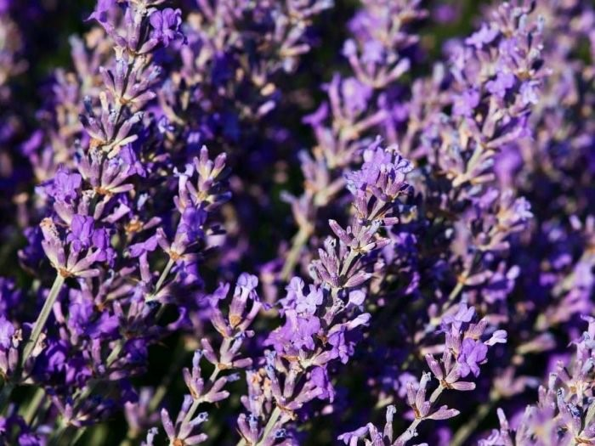

What is Lavender?
Nearly forty plants with the mint family are technically classified as lavender, although the most common form is Lavandula angustifolia, on which the color “lavender” is based. [1] This genus is found in Europe, Africa, the Mediterranean, and parts of Asia. The reason that it is so widely used is its massive range of applications, from food and fragrance to cosmetics and herbal medicines; this plant is full of essential oils that can have powerful effects on the human body and has the most unique and beloved scents in the world.
One of the problems with lavender is that it can grow and spread quickly, which is why it is considered a weed in certain parts of the world. As a culinary element, it is used in salad dressings, honey, sauces, beverages, various teas, and as a flavoring spicefor a number of cultural dishes. Lavender essential oil is highly sought after and widely available. [2]

Health Benefits of Lavender
The scent and flavor of lavender are wonderful, but the bonus comes from its wide range of health benefits, which we will explore in greater detail below.

Reduces Anxiety & Stress
There are a number of methods of using lavender to soothe anxiety and stress. [3] The natural organic compounds in its leaves and flowers can be ground between the fingers and then rubbed onto the temples. This topical application can soothe the body and mind by relieving anxious thoughts and balancing the mood. Apart from this topical application, you can also brew lavender tea and achieve much the same effect. The antioxidant components in it can impact the endocrine system to lower the levels of stress hormones in the body.
If you regularly struggle with insomnia, apnea or restless sleep patterns, it can negatively impact your life. [4] By brewing a few lavender flowers in hot water, you can steep a wonderful tea that has been used to induce sleep and relaxation for thousands of years. This is closely linked to the flower’s impact on the nervous system, and can also help clear your mind of negative thoughts. It is commonly used in meditation techniques and its essential oils are used in aromatherapy.
Everyone is looking for a reliable way to relax the body and mind, and lavender takes care of both. If you add these flowers to your bathwater and take a nice long soak, the anti-inflammatory components can help in reducing the inflammation. [5] The antioxidant properties of lavender are also quite potent and it is one of the most trusted applications of its flowers.

Skin Care
An easy, mobile way to always take care of your skin is to fill a spray bottle with lavender flowers. [6] When your skin is feeling dry or irritated, simply spray some of the infused water on the area and enjoy the quick relief that it provides. This can also work for chronic conditions like psoriasis, eczema, and acne.
Although many people turn to lavender for relaxation and aromatherapeutic applications, its effect on treating infection is impressive, to say the least. Many people apply crushed leaves on wounds and injuries for quick healing of the wounds as well as to prevent the development of infections on them. [7]

If you suffer from hair loss or any other condition that affects the quality of your hair, seek out a lavender-based shampoo. However, some of the organic cosmetic products can be quite expensive, while others which claim to be derived from it may still contain harsh chemicals. You can steep lavender flowers like a tea and then apply the mixture to your hair. [8] This will function as an effective shampoo and significantly boost the health of your follicle beds and hair.

The relaxing qualities of lavender, which come from its organic compounds and antioxidants, also help the heart by reducingblood pressure and easing the tension on blood vessels. [9] This can prevent atherosclerosis and other cardiovascular problems, thereby lowering the risk of stroke and heart attack.
- 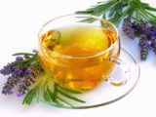6 Proven Benefits of Lavender Tea
- 11 Best Essential Oils for Sleep

Prevents Digestive Issues
The polyphenols found in lavender have a wide range of effects on the body. It can prevent the development of harmful bacteria and accumulation of gas in the gut. [10] This will ease stomach discomfort, reduce bloating, and eliminate cramping. Chewing on its leaves or drinking its tea can be effective too.

Word of Caution: Although, not commonly considered an allergenic substance, if you are susceptible to allergens in the mint family, you could experience negative side effects from using lavender as well. These are usually mild in nature and include constipation, headache, and increased appetite, while the topical application can cause irritation and redness.

